PROYEK SISTEM PENGISIAN KRS

DESAIN BASIS DATA



DISUSUN OLEH :

VIVI SISKA 145314061

NATALIA ARI CHRISMIYATI 145314064

IMANUEL DEMI PRASETYA 145314076

PROGRAM STUDI TEKNIK INFORMATIKA

FAKULTAS SAINS DAN TEKNOLOGI

UNIVERSITAS SANATA DHARMA

YOGYAKARTA

1. Diagram Kelas
2. Mahasiswa.java

|  |
| --- |
| **Mahasiswa** |
| * username : String * password1 : String * password2 : String * nim : String * nama : String * email : String * dosen : String * ips : String * ipk : String * SKS : String |
| * getUsername() : String * setUsername(String) : void * getNim() : String * setNim(String) : void * getNama() : String * setNama(String) : void * getEmail() : String * setEmail(String) : void * getDosen() : String * setDosen(String) : void * getIps() : String * setIps(String) : void * getIpk() : String * setIpk(String) : void * getSKS() : String * setSKS(double) : void |

1. MataKuliah.java

|  |
| --- |
| **MataKuliah** |
| * kodeMakul : String * namaMakul : String * waktu : String * sks : String * dosen : String * tarif : String * ruang : String |
| * getKodeMakul() : String * setKodeMakul(String) : void * getNamaMakul() : String * setNamaMakul(String) : void * getWaktu() : String * SetWaktu(String) : void * getSks() : String * setSks(String) : void * getDosen() : String * setDosen(String) : void * getTarif() : String * setTarif(String) : void * getRuang() : String * setRuang(String) : void |

1. Physical design

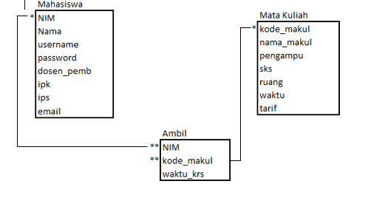

Tabel Mahasiswa

|  |  |  |  |  |  |  |  |
| --- | --- | --- | --- | --- | --- | --- | --- |
| NIM | Nama | username | password | Dosen_pemb | ipk | ips | email |
|  |  |  |  |  |  |  |  |
|  |  |  |  |  |  |  |  |

Tabel Mata Kuliah

|  |  |  |  |  |  |  |
| --- | --- | --- | --- | --- | --- | --- |
| Kode_makul | Nama_makul | pengampu | sks | ruang | waktu | tarif |
|  |  |  |  |  |  |  |
|  |  |  |  |  |  |  |

Tabel Ambil

|  |  |  |
| --- | --- | --- |
| NIM | Kode_makul | Waktu_krs |
|  |  |  |
|  |  |  |

1. ER Diagram

